***PROJECT REPORT ON***  
***Mini Project on Bank Management System***

***By-***

***Sumit Dahiya ( PSno. 99007518)***

|  |  |  |
| --- | --- | --- |
| S.No. | Table of content | Page No. |
| 1 | Introduction | 2 |
| 2 | Badges | 3 |
| 3 | Requirements | 4-5 |
| 4 | Cost and Features | 6 |
| 5 | SWOT analysis | 7 |
| 6 | 4W’s and 1H | 8 |
| 7 | Detail requirements (HLR &LLR) | 9 |
| 8 | Architecture | 10-12 |
| 9 | Implementation | 13-16 |
| 10 | Test plan and output | 17 |
| 11 | Reference and Learning source | 18 |

Introduction

BANK MANAGEMENT SYSTEM, the main aim of this project is to develop software for bank management system. This project is to develop software for bank management system. This project has been developed to carry out the processes easily and quickly, which is not possible with the manuals systems, which are overcome by this software. This project is developed using c language and. Hence it provides the complete solution for the current management system.



This bank management system also allow user to add new customer account, delete account and user can also modify existing user account information. Using this system user can also search any individual account in few seconds.

BADGES

|  |  |  |
| --- | --- | --- |
| Build | CPP Check | Codiga |
|  |  |  |

FOLDER STRUCTURE

|  |  |
| --- | --- |
| Folder | Description |
| 0_Certificates | All certificates screenshot |
| 1_Requirements | Documents detailing requirements and research |
| 2_Architecture | Document specifying design detail |
| 3_Implementation | All codes and documentation |
| 4_TestPlanAndOutput | Documents with test plans and output |
| 5_Report | Documents related to project report |
| 6_ImagesAndVideos | All images |
| 7_Others | Contain files |

REQUIREMENTS

## INTRODUCTIONS

BANK MANAGEMENT SYSTEM, The main aim of this project is to develop software for bank management system. This project is to develop software for bank management system. This project has been developed to carry out the processes easily and quickly, which is not possible with the manuals systems, which are overcome by this software. This project is developed using c language and. Hence it provides the complete solution for the current management system.

In bank management system we have two sub part admin and customer where the admin access is secured by login page whereas customer page can be access by entering a valid account number.

The admin can create an account as well as can perform any updated to that account if required. On the other hand, the customer can view his balance, details and can withdraw his/her money as per his need.

This topic was chosen because it gives me an opportunity to implement and understand multiple C programming concepts.

## RESEARCH

Bank Management System Features and Benefits

In the recent years, computers are included in almost all kind of works and jobs everyone come across in the routine. The availability of the software’s for almost every process or every system has taken the world in its top-gear and fastens the

day-to-day life. So, we have tried our best to develop the software program for the Bank Management System where all the tasks to manage the bank system are performed easily and efficiently. It manages all the transactions like new account entry, deposit as well as withdraw entry, transaction of money for various processes, account management, managing bills cash or cheque, etc. Thus, above features of this software will save transaction time and therefore increase the efficiency of the system.

***Benefits***

Bank Management System offers a range of benefits to providers medium and small. Here are just a few of them:

***Better Account Management***

This application provides you a mechanism store, update and delete account details as per your requirement.

***Less burden on employs***

Application is automated so no manual work is required.

***Reduce Time***

Searching of an account is very easy as well as updation of account balance is automated.

***Secured***

Applicated is secured using login page so only authorized person can view, update the account

***organized***

Organization of file is automated no manual work required.

Cost and Features with Time

|  |  |  |
| --- | --- | --- |
| Time | Feature | Cost |
| 2000BC | The beginning of banking system | free |
| 1397-1463 | The modernization of bank | free |
| 2001-2021 | The emergence of Bank management system | $5-$10 |

Defining Our System

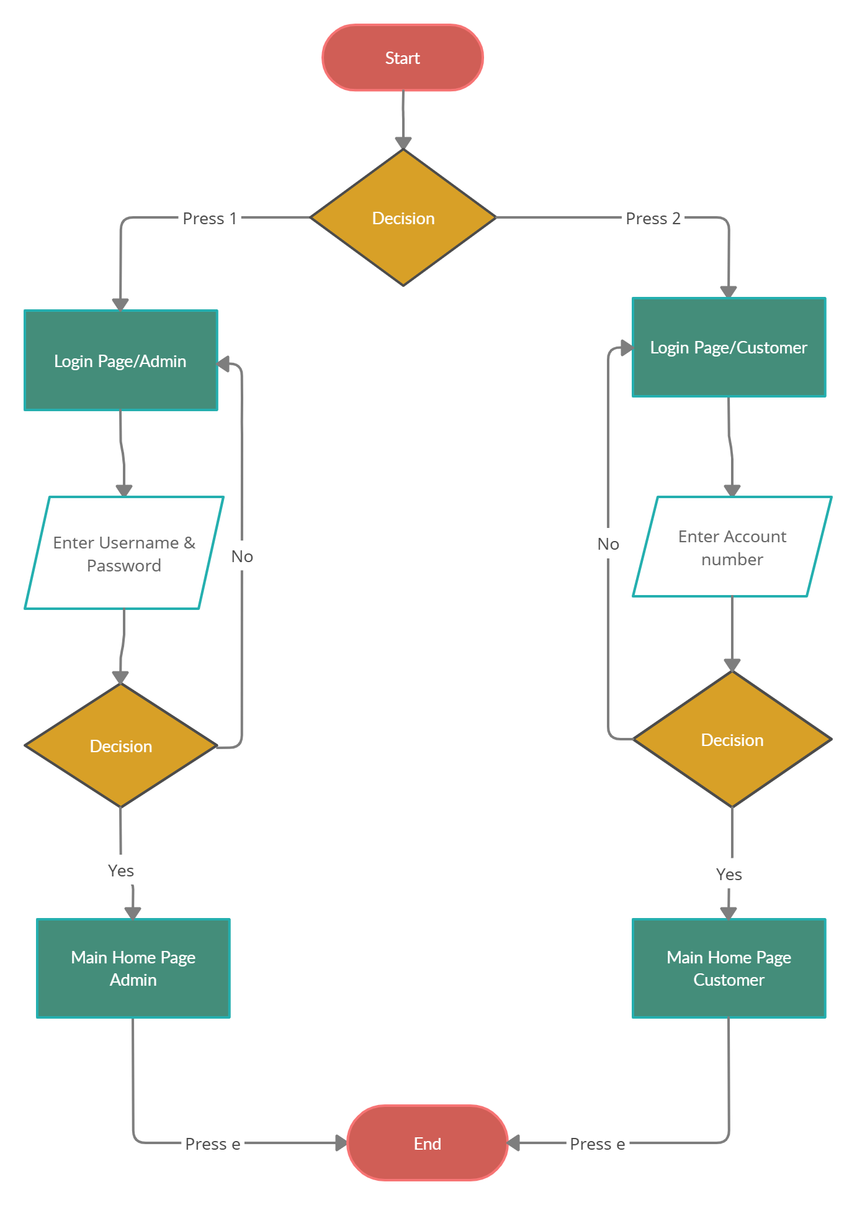

Explanation:

Bank Management System have few inbuilt features like:

* Create new account
* Update information of existing account
* Removing existing account
* Check the detail of existing account
* List of all account
* Delete all account
* Open calculator
* Change login credentials
* Making a withdrawal

SWOT Analysis

***Strengths***

Easy withdrawals Removal of paper transaction Save time & Man power

***Weaknesses***

Hardware is required Technically aware employee required

***Opportunities***

User friendly Can be used by multiple banks More secure as compared to paper transactions

***Threats***

Admin can misuse his power to manipulate the customer data Less visually appealing GUI

4W's and 1'H

* Who:

Small/Medium size bank can use this application

* What:

They can use it to manage the account of their customer and can provide a way for the customer to make a withdrawal

* When:

This problem emerges when the customer base of bank increased rapidly and multiple transactions take place simultaneously

* Where:

Bank Management System can be Run on both Os Linux and window as well as

* How:

It will help banks to keep their customer account updated and will also enable customer to make a withdrawal

Detail requirements

* High Level Requirements:

|  |  |  |  |
| --- | --- | --- | --- |
| ID | Description | category | Status |
| HLR1 | Bank Management System | Technical | Developed |

* Low Level Requirements:

|  |  |  |
| --- | --- | --- |
| ID | Description | Status |
| LLR1 | Login System Admin | Developed |
| LLR2 | Login System Customer | Developed |
| LLR3 | Account Management System | Developed |
| LLR4 | Withdrawal mechanism | Developed |
| LLR5 | Calculator | Developed |

ARCHITECTURE

* High Level Architecture

Behavioral Diagram

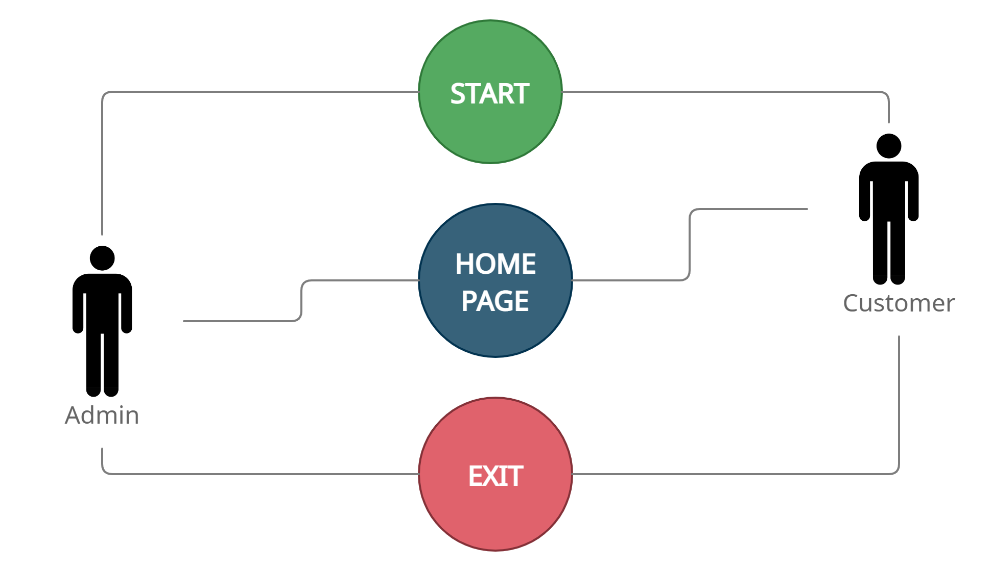

Structural Diagram

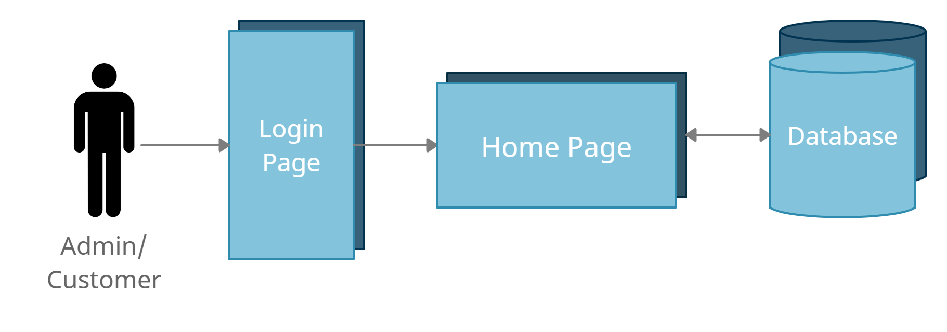

* Low Level Architecture

Behavioral Diagram

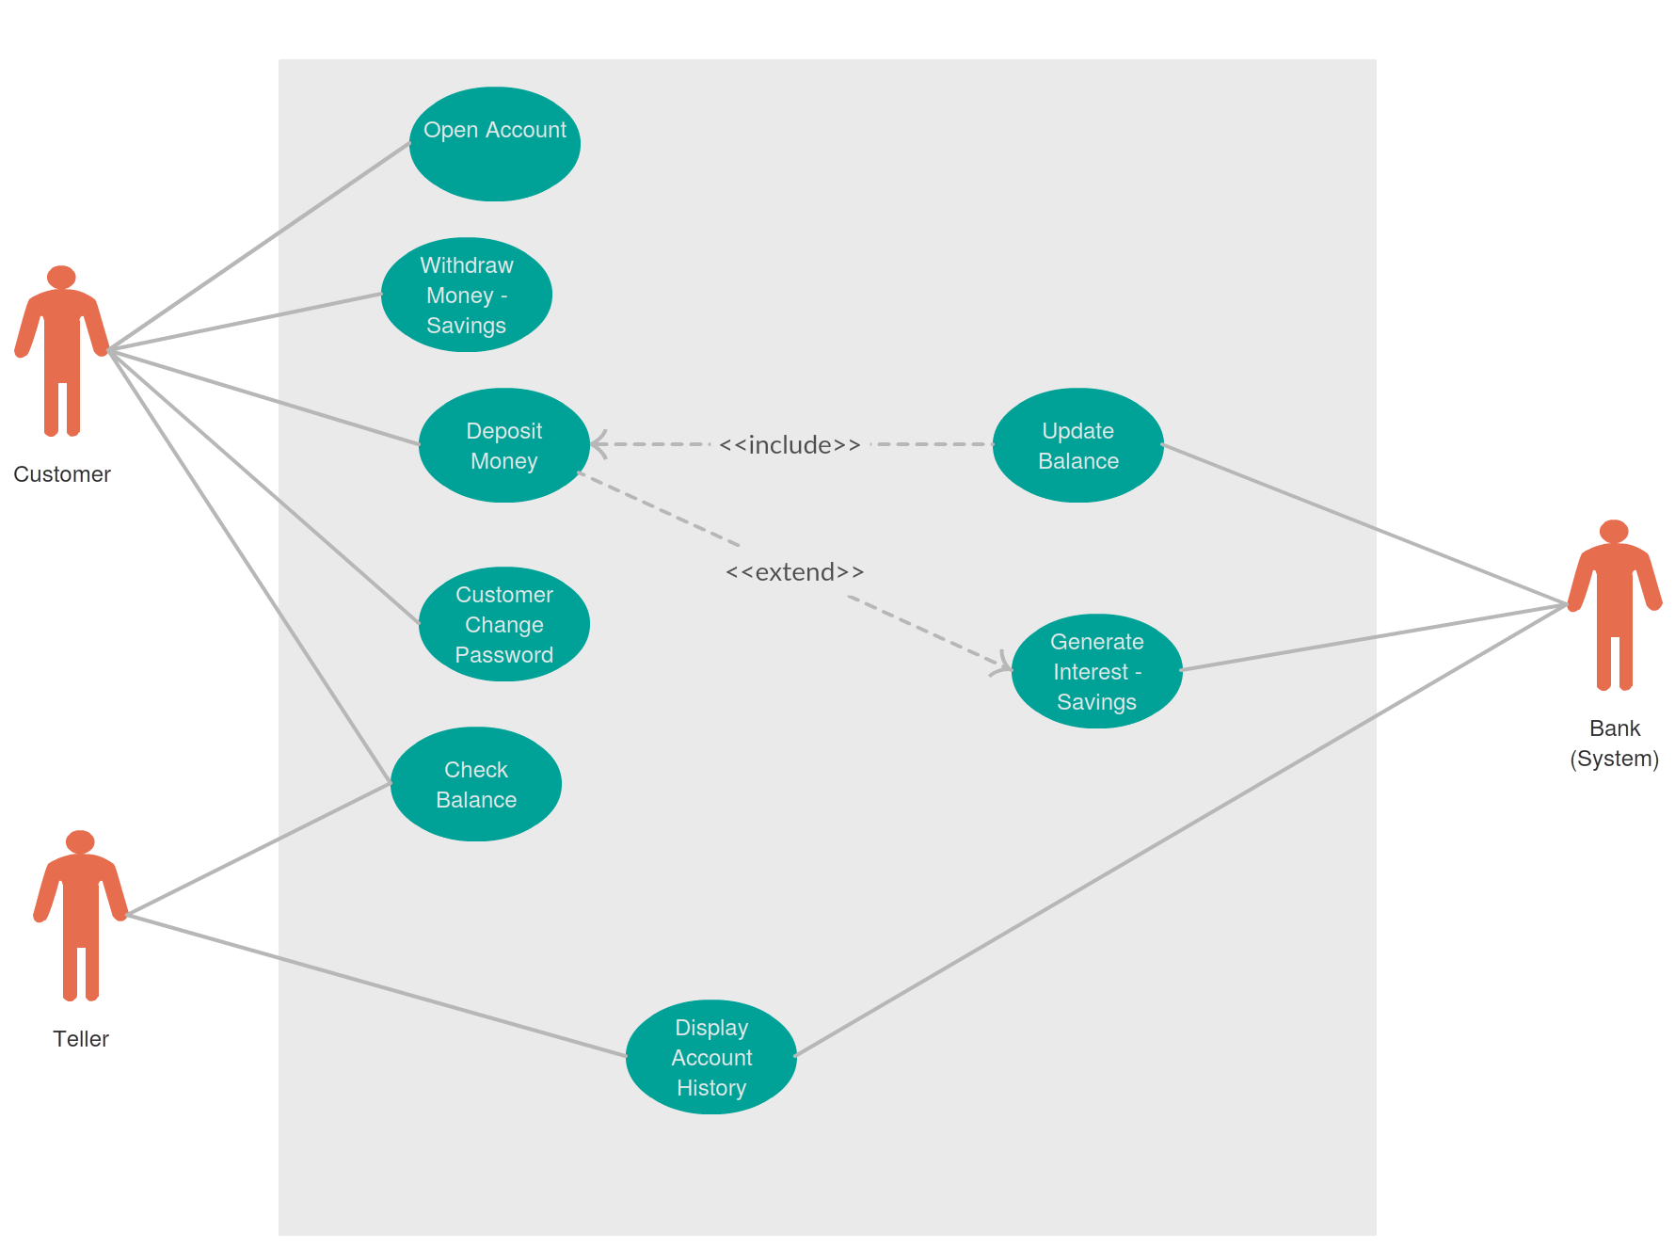

Structural Diagram

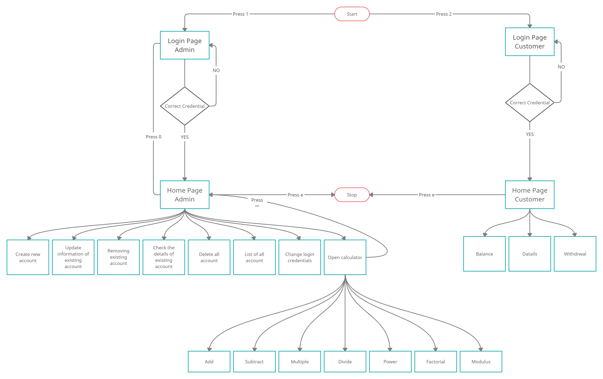

***Implementation and Working***

Below mentioned is some working of Bank management system

* Login page

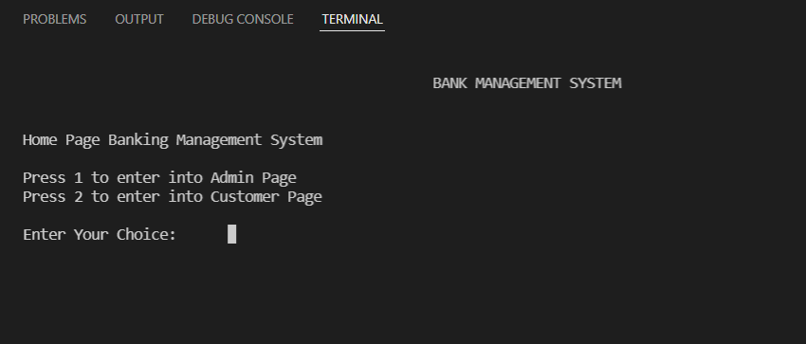

If you press 1 and after putting login credential you will be redirected to admin server.

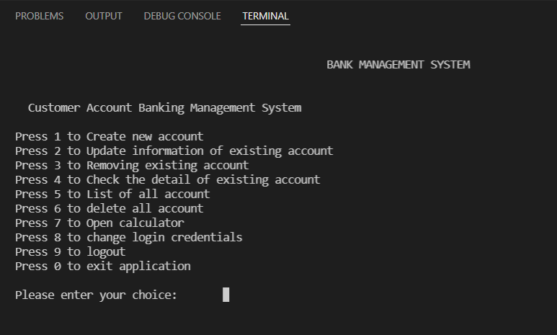

Now let's make a new account

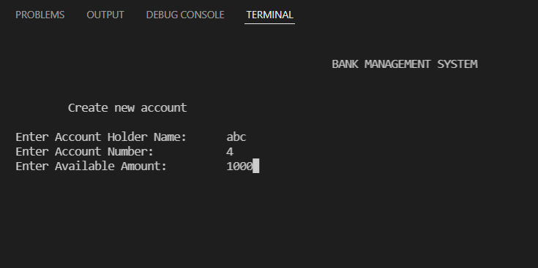

After filling the required fields your data will be saved in record of Bank.



To see your saved record, you can refer to file which is present in 7_Other>data-set

And opening Account_detail.dat file

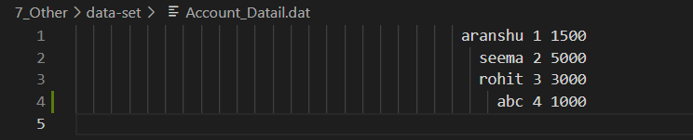

Now let's Login as user and withdraw some money from account.

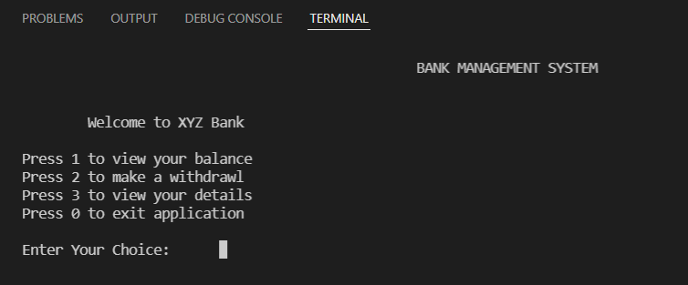

Let us check the money amount in our account by pressing 1

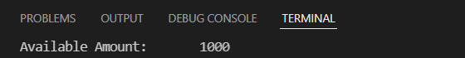

Now let us withdraw money from account by pressing 2 and filling the amount.

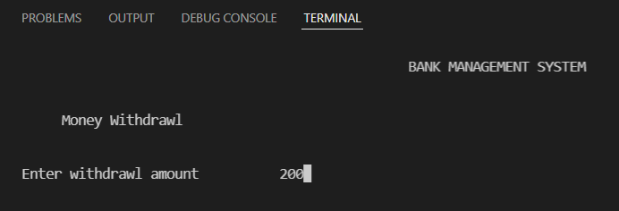

You can check in your balance again and it will show updated amount and you can check Account_Detail.dat file that your data is updated.

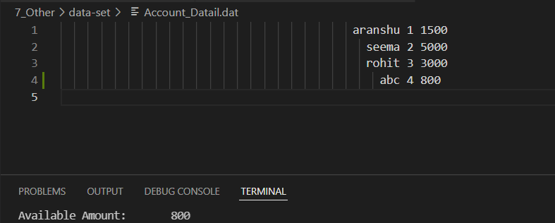

Test Plan and Outputs

* High level test plan

|  |  |  |  |
| --- | --- | --- | --- |
| Test ID | Description | Exp I/P | Exp O/P |
| HLT1 | Check the calculator | Two number | One result |
| HLT2 | Check the account operations | nil | nil |
| HLT3 | Cehck the login credentials | Username & Password | True/False |

* Low level test plan

|  |  |  |  |
| --- | --- | --- | --- |
| Test ID | Description | Exp I/P | Exp O/P |
| LLR1 | Addition | 1,2 | 3 |
| LLR2 | Subtraction | 5,1 | 4 |
| LLR3 | Multiplication | 6,3 | 18 |
| LLR4 | Division | 4,2 | 2 |
| LLR5 | Power | 2,3 | 8 |
| LLR6 | Factorial | 5 | 120 |
| LLR7 | Create account | data | Create new account |
| LLR8 | Update account | data | Update selected data |
| LLR9 | Delete account | data | Delete the account |
| LLR10 | Withdrawal money | data | Update balance |
| LLR11 | Login Admin | Username & password | true/false |
| LLR12 | Login Customer | Account number | true/false |

Reference and Learning source:

1. [Geeksforgeeks](https://www.geeksforgeeks.org/c-programming-language/)
2. [TutorialsPoint](https://www.tutorialspoint.com/cprogramming/index.htm)
3. [Repository of Bharat Gopal](https://github.com/Bharathgopal/M1_Teaching_Util.git)